# Name : N.V.M.SUMANTH

# REG NO : 192111449

**EXP .NO:03 DATE:28/04/2023**

**CREATE A VIRTUAL HARD DISK AND ALLOCATE THE STORAGE USING VM WARE WORKSTATION**

**AIM:**

To Create a virtual hard disk and allocate the storage using VM WARE workstation

**PROCEDURE:**

1. Goto vm ware work station
2. Right click the vm and goto the settings
3. Add hardware wizard and select scsi and click next
4. Create new virtual disk
5. Selct the disk size as 2.0. And selct split virtual disk intomultifiles.
6. Give name and click the finish

**IMPLEMENTATION:**

**STEP 1:**

**GOTO VM WARE WORKSTATION**

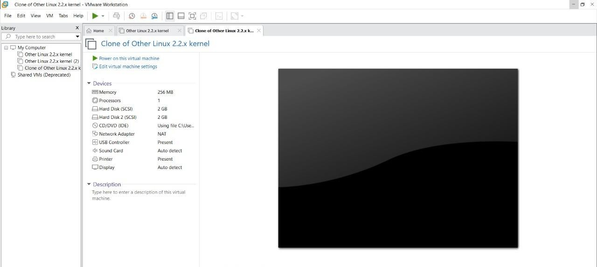

**STEP2: RIGHT CLICK THE VM AND GOTO THE SETTINGS**

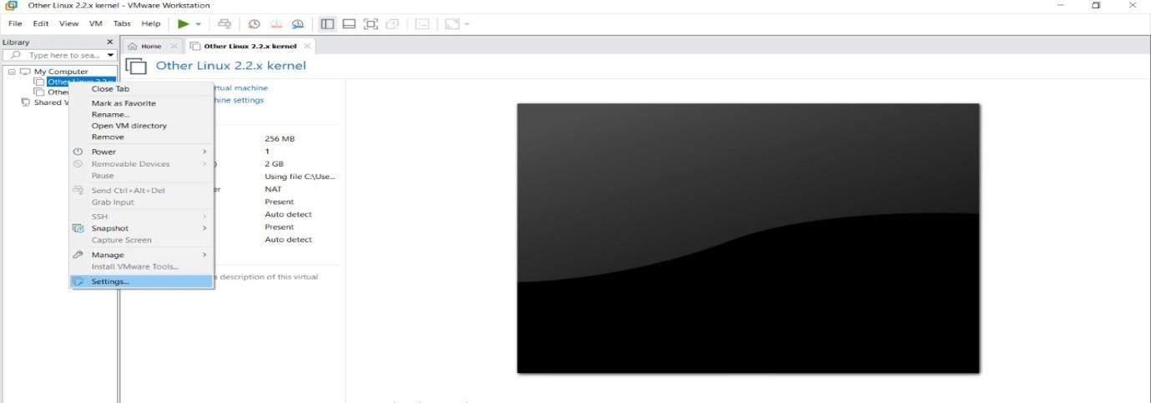

**STEP 3: ADD HARDWARE WIZARD AND SELECT SCSI AND CLICK NEXT**

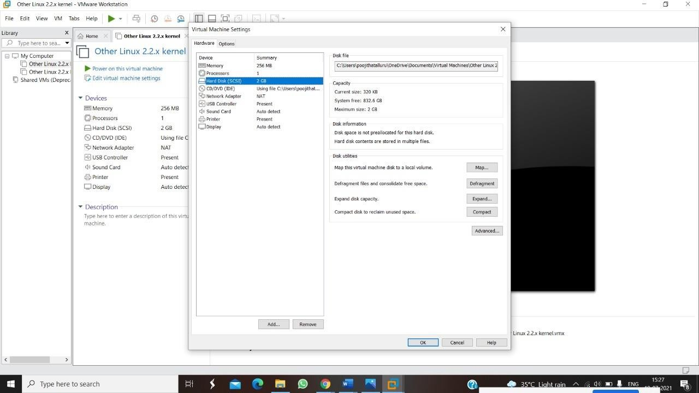

**STEP 4: CREATE NEW VIRTUAL DISK**

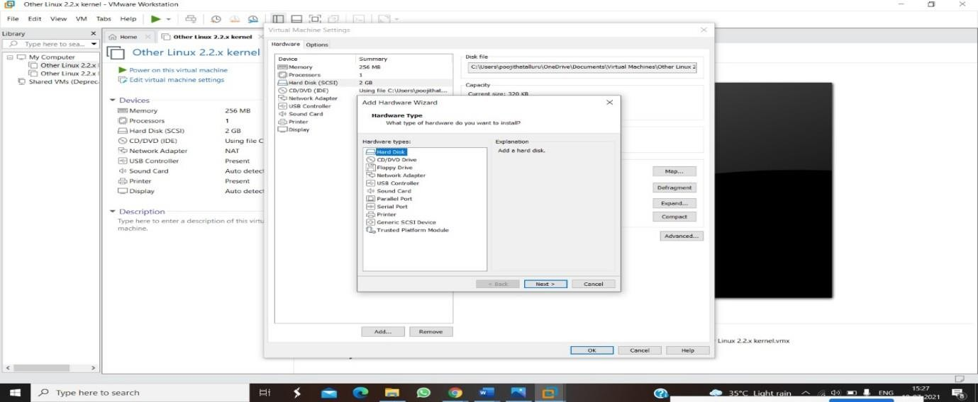

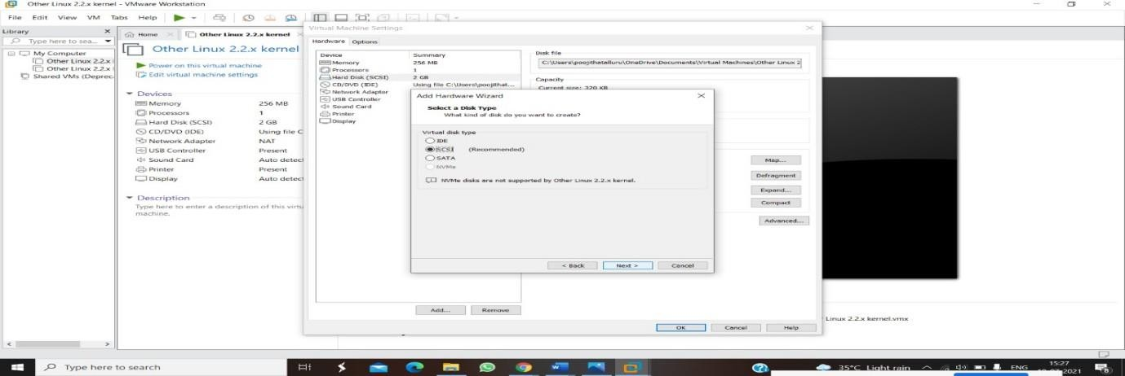

**STEP 5: SELCT THE DISK SIZE AS 2.0. AND SELCT SPLIT VIRTUAL DISK INTO MULTIFILES.**

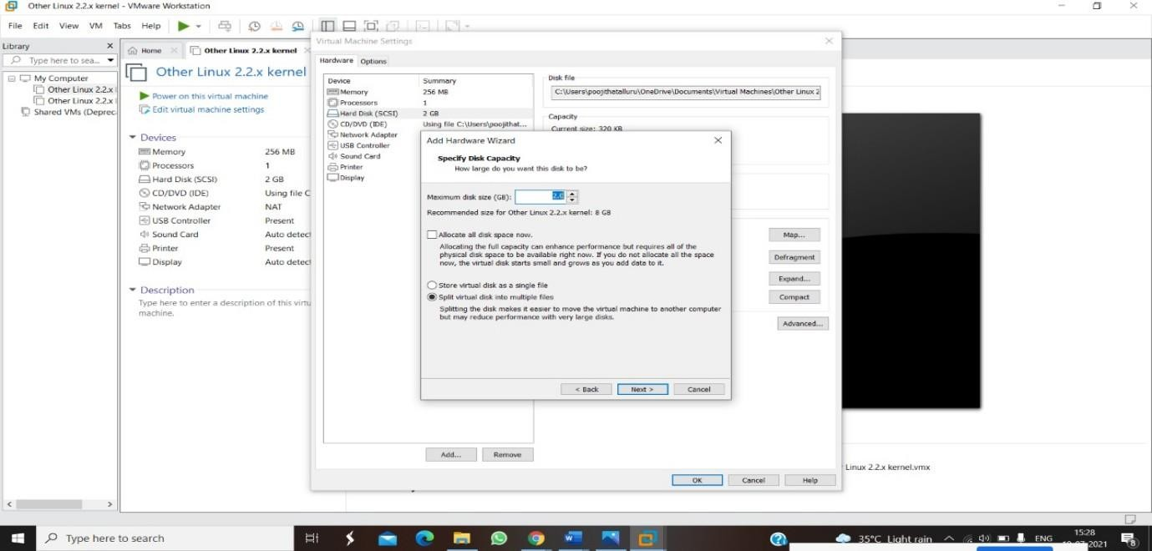

**STEP 6: GIVE NAME AND CLICK THE FINISH**

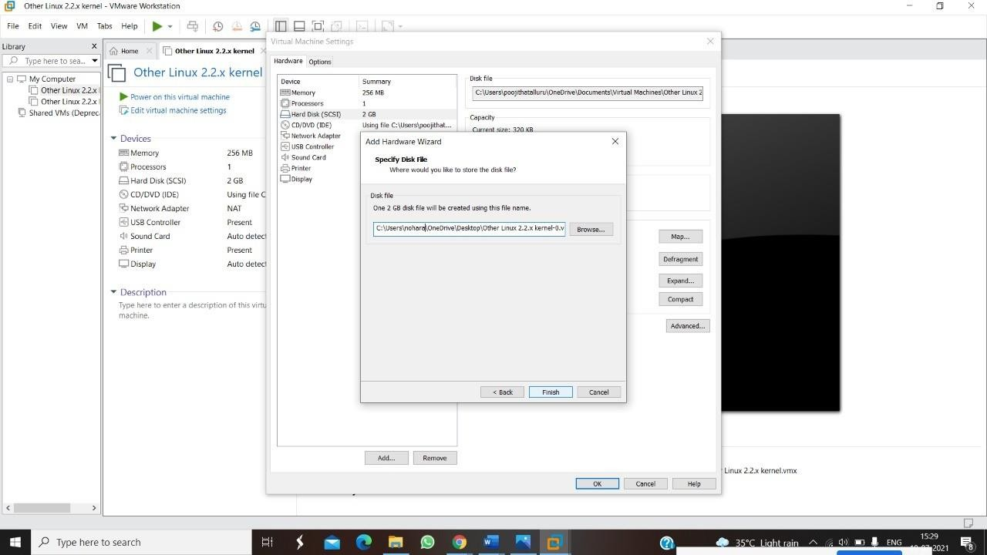

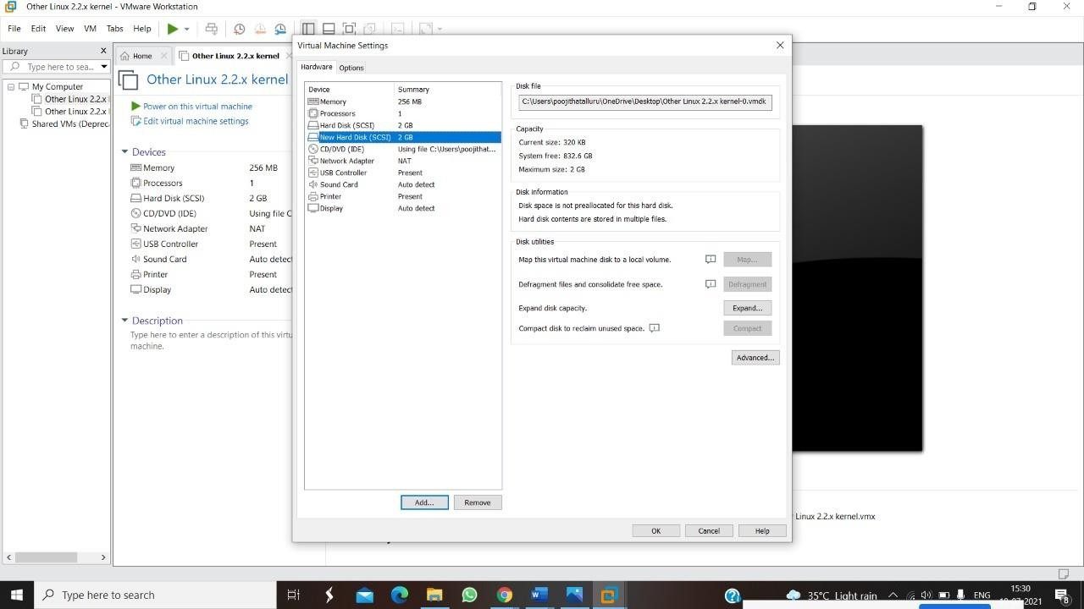

**OUTPUT**

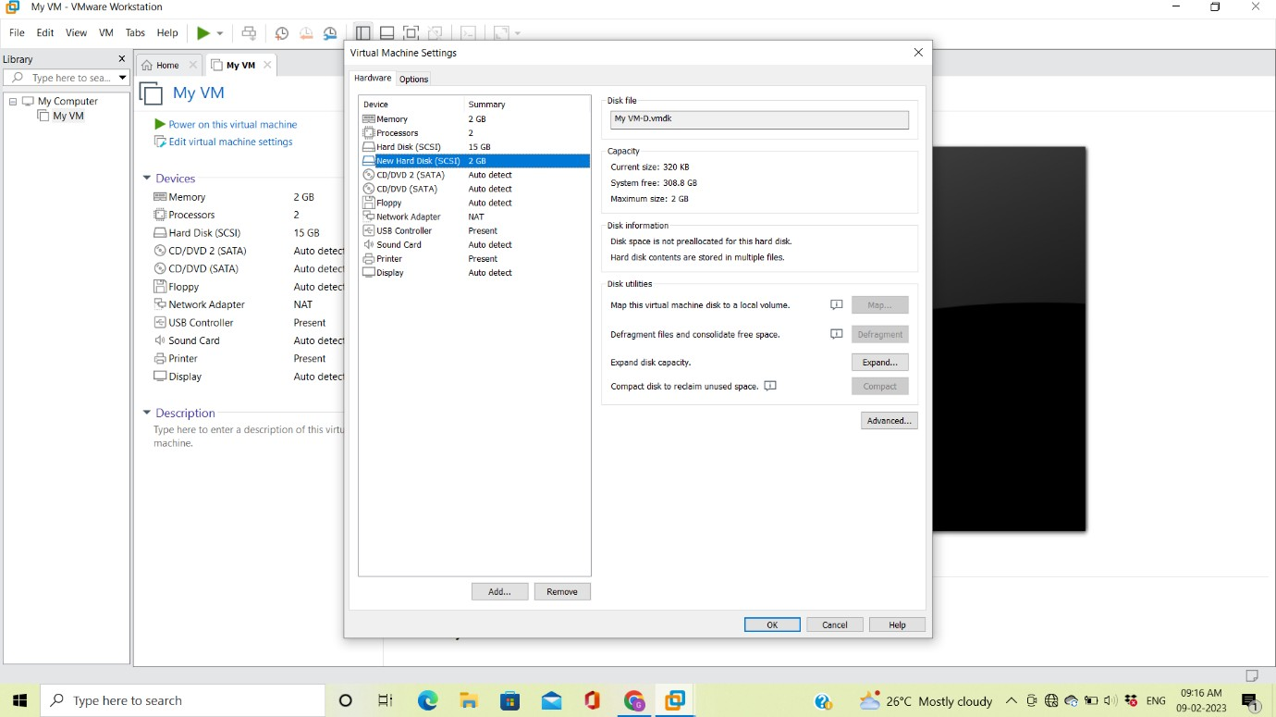

**RESULT**

Hence creation of a virtual hard disk and allocate the storage using VM WARE workstation is performed successfully.